**Project Report**

**Calculator for Electrical Circuit Analysis**

**Name: Jawad Ali**

**CMS ID: 033-22-0001**

1. **Introduction:**

Electrical circuit Analysis can be complicated in calculation without dedicated Calculator for it. Using this program users can choose calculation option from a main menu (like series resistor or series capacitor), Enter values of components. Program will display appropriate message with result and save it in history (in history file). The program can also provide history at any point.

1. **Features:**

Main menu: Displays calculation option and receives input.

About 12 Electrical Analysis formula calculation.

History: Every Calculation is added to txt history, can be displayed when user need.

**3. Package named Analysis**

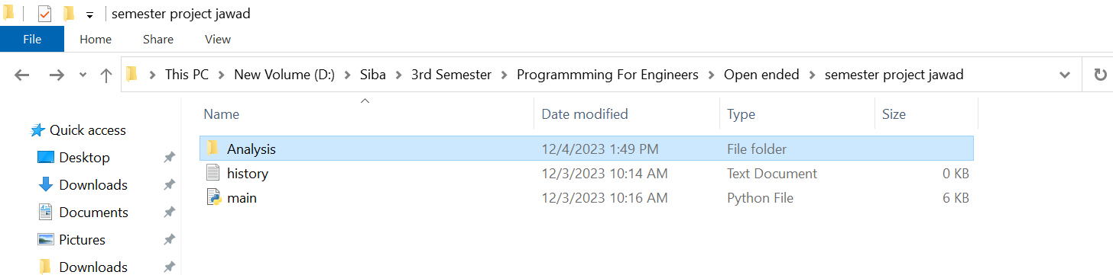

**4. module named network analysis**

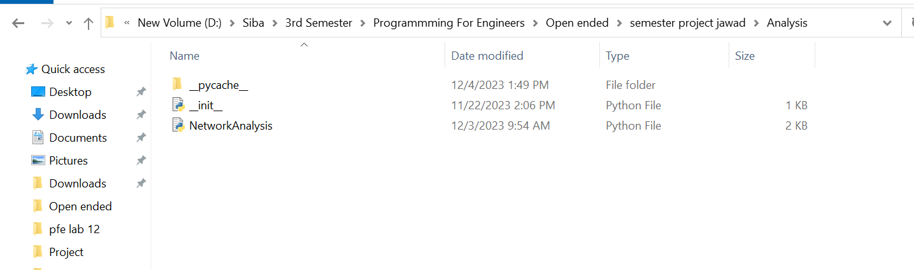

**Functions (in module):**

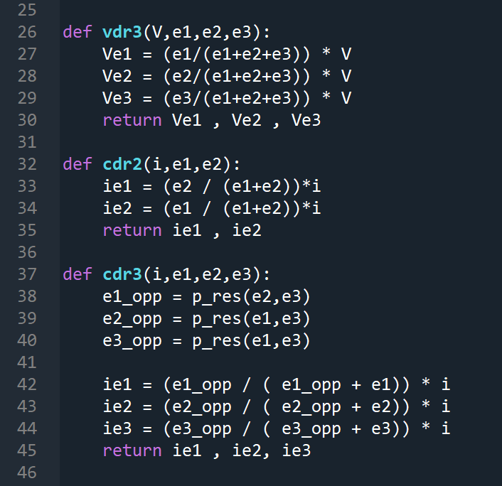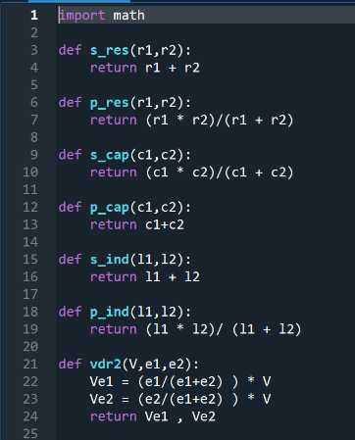

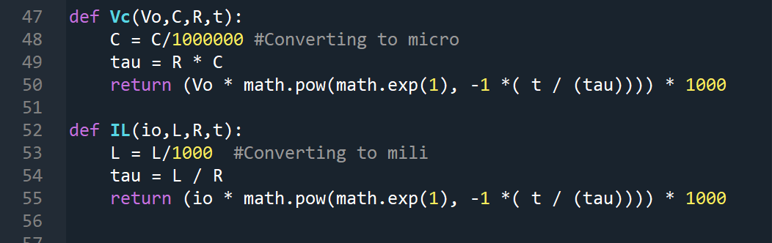

4**. Main program for cmd based interface:**

**a. importing module**

b. opening txt file history



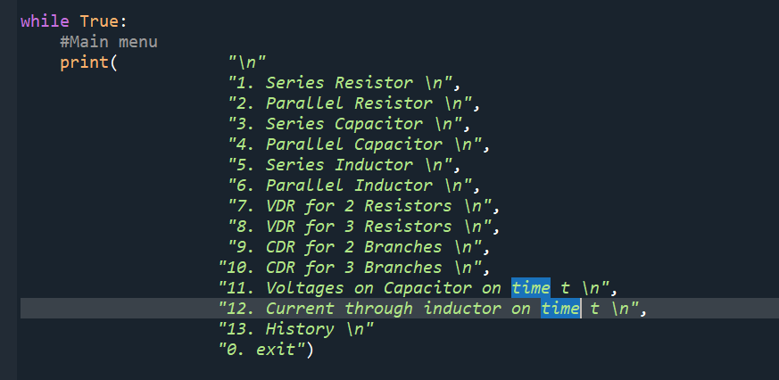 c. Main menu

d. Getting input :

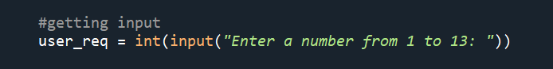

e. Input Validation

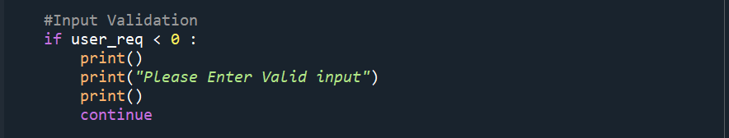

f. using function from module to calculate and display result

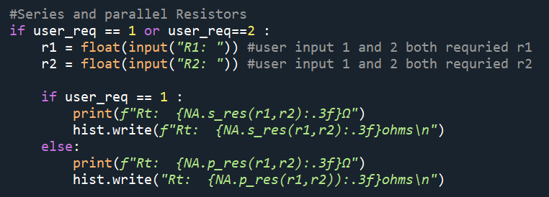

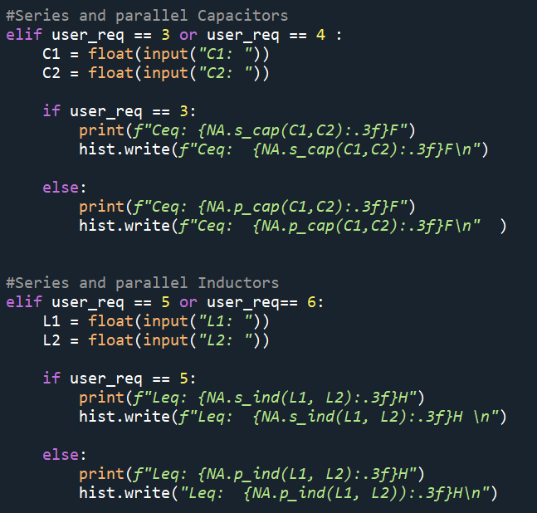

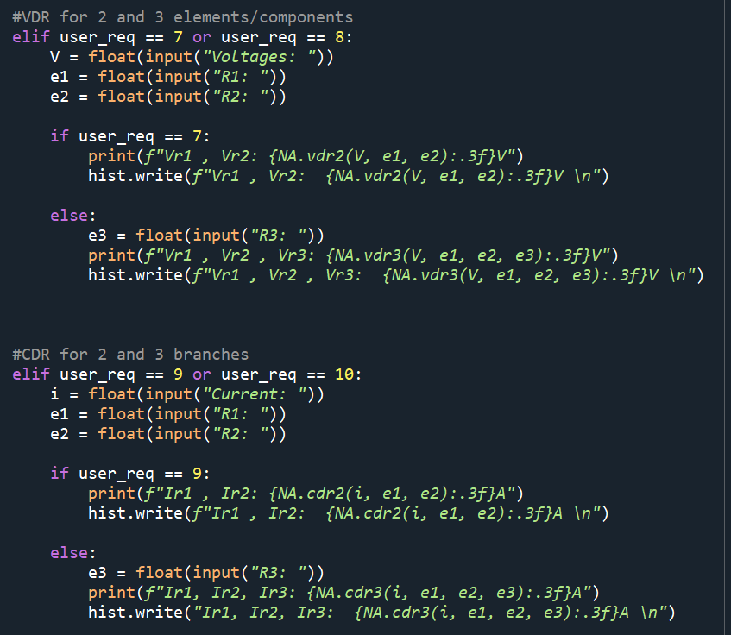

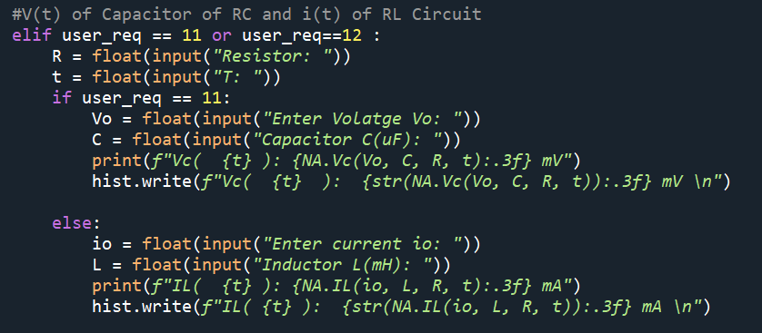

**History:**

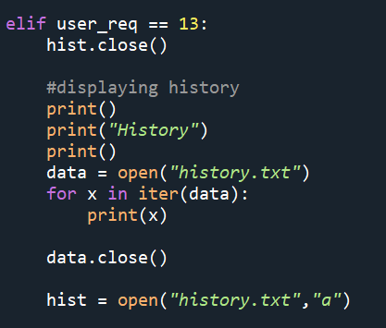

To exit program:

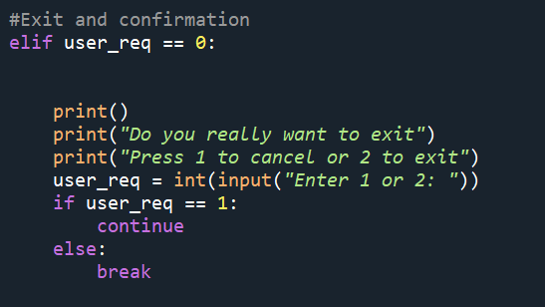

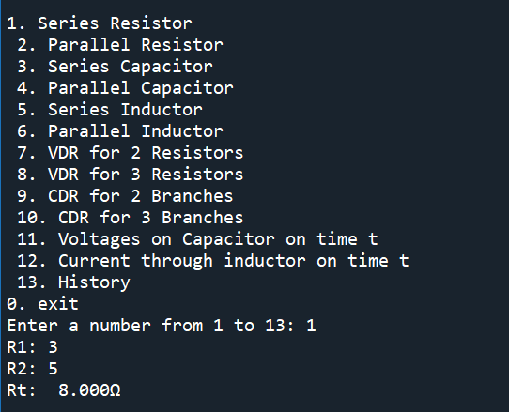Output:

